SpiritstoneHealing
(403) 816-3435
spiritstone@mail.com
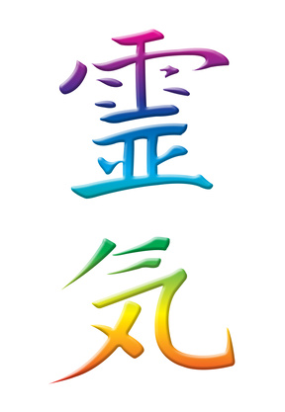
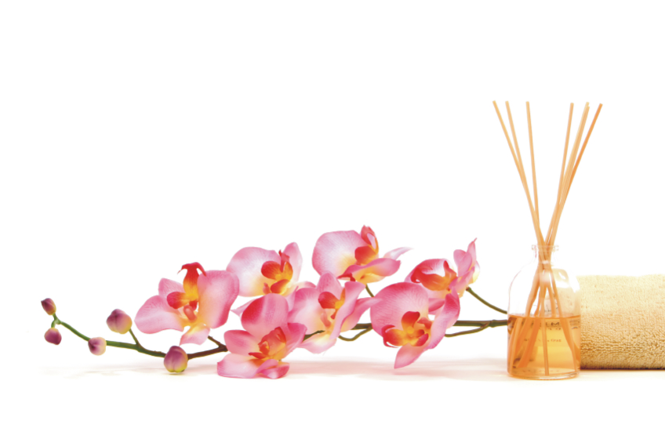

What is Reiki?
Reiki is a Japanese technique for stress reduction and relaxation that also promotes healing. It is administered by "laying on hands" and is based on the idea that an unseen "life force energy" flows through us and is what causes us to be alive. If one's "life force energy" is low, then we are more likely to get sick or feel stress, and if it is high, we are more capable of being happy and healthy.
The word Reiki is made of two Japanese words - Rei which means "God's Wisdom or the Higher Power" and Ki which is "life force energy". So Reiki is actually "spiritually guided life force energy."
A treatment feels like a wonderful glowing radiance that flows through and around you. Reiki treats the whole person including body, emotions, mind and spirit creating many beneficial effects that include relaxation and feelings of peace, security and wellbeing. Many have reported miraculous results.
Reiki is a simple, natural and safe method of spiritual healing and self-improvement that everyone can use. It has been effective in helping virtually every known illness and malady and always creates a beneficial effect. It also works in conjunction with all other medical or therapeutic techniques to relieve side effects and promote recovery.
There are many wonderful benefits of Reiki. Reiki is a very simple process, but usually produces quite profound effects. The main purpose of Reiki is not only to heal diseases, but also to promote a positive mind and healthy body so that people can experience joy in life.
However, Reiki does not promise a miraculous cure from disease. Conditions that have taken years to manifest in the physical body cannot be cured in a few sessions. The person has to want to be well and will probably also need to make some lifestyle changes so that the source of stress and negative emotion (dis-ease) does not recur. It takes time for the Physical, Emotional, Mental and Spiritual bodies to be brought back into balance.
What to Expect During a Reiki Healing Session?
You will be asked to lay down on a massage table , couch, or bed. You will be fully clothed except for your shoes. You may also be asked to remove or loosen your belt so that your breathing is not restricted in any way. It is best to choose loose-fitting garments to wear on the day of your appointment. Wearing natural fabrics is best (cotton, wool, or linen). You may also be asked to remove any jewelry (rings, bracelets, pendants, etc.) prior to the session, so consider leaving these items at home.

What Happens After a Reiki Healing Treatment?
Many clients wonder or question what they may expect or experience during or after their Reiki session. Quite often people are unwilling to submit themselves for alternative therapies simply because they are afraid - afraid from the unexpected or the unknown. But fear is merely caused from a lack of awareness, a lack of knowledge, a lack of education or a lack of understanding. I often state that people should be involved in their own healing program, where they accept responsibility by actively participating. Of course many are resistant to this and would rather let the practitioner create the "miracle" healing. But to fully comprehend the importance of being involved so that success can be accomplished, people should realize that they must become proactive with educating themselves - this is part of being responsible to self. So here are some helpful tips to follow after receiving a Reiki healing session. Included is a daily protection plan designed to protect, cleanse and balance you physically, mentally, emotionally and spiritually. If practised on a continuous daily basis, they will help you to maintain and enhance your overall well-being.
Benefits Of A Reiki Session
1. Aligns, clears and balances chakra centres (we focus on the 7 major energy centres)
2. Alleviates associated pain
3. Promotes relaxation and balance
4. Releases energy blockages, lower vibrating energy (also called negative energy), plus toxins or impurities
5. Relieves stress
6. Supports and activates your body's natural ability to heal itself
Side Effects That May Be Experienced After Treatment
1. Crying for no reason
2. Diarrhea
3. Extreme tiredness
4. Feeling hot or cold
5. Increased urination
6. Tingling
7. Travelling aches or pains throughout body

Reason
1. Energy is shifting throughout your body and re-balancing
2. Cleansing process has been triggered
3. Toxins are being released
What To Do
1. Side effects will usually diminish after 48-hours
2. Drink at least six to eight - 8 oz. glasses of water per day to help flush toxins from your body, plus help to conduct your body's energy flow
3. Eat nourishing foods
4. Avoid over consumption of stimulants such as coffee/tea/soft drinks containing caffeine or alcohol
5. Increase alone time in order to separate your energy from others
6. Increase rest time
7. Relax - just enjoy and be good to yourself; listed below are some relaxation ideas:
1. Listen to soothing music
2. Take a relaxing bath
3. Read
4. Go walking
5. Go for a massage
6. Have a reflexology treatment
7. Go swimming
8. Go to the sauna
9. Do gardening

